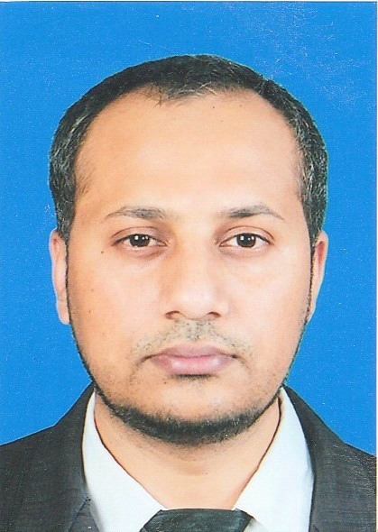
Mr. Waqas Ayub Gondal

Gender: Male
Date of Birth: 20th July 1983
Age (Yr.): 33
Marital Status: Married
Visa Status: Permanent – Family (TH)
Nationality: Pakistani
Religion: Islam
Height: 185 cm.
Weight: 82kg.

Address: House 212/202 M.3 Rasika (Tepharak) Village, Bangplee-Tumru Rd., Praggasamai, Muang, Samutprakarn, 10280 Thailand.
Contact Detail: Mobile Phone : +66819764844
E-mail: jeewaqas@hotmail.com
Skype id: Jeewaqas2

Education
Year 2016 Education Level: Master’s Degree (Ongoing)
University: Panyapiwat Institute of Management, Thailand (Bangkok)
Certificate: Master of Business Administration
Major: International Business

Year 2015 Education Level: High Vocational (Studying)
Institute: NEBOSH INTERNATIONAL UK.
Certificate: International General Certificate
Major: Health and Safety at Workplace

Year 2006 Education Level: Bachelor of Science
University: University Of Punjab Lahore, Pakistan
Certificate: Bachelor of Science
Major: Chemistry

Objective | To work as a professional in a reputed business organization with enough opportunities to grow with the company’s progress and to be part of an efficient team while working with multiple departments to gain multi-disciplinary and cross-functional experience.
Professional  Achievements | International Marketing ( International – Asia & Middle east )  Key Responsibilities :  - Identifying new sales leads internationally  - Pitching products and/or services  - Maintaining fruitful relationships with existing customers  - NEW Product launch for Australian customer with high value sale and volume in 2016.  - Dealing with international clients on daily basis and providing best support, developing new products for furniture application with enormous potential.

Work Experience
Period: June 2008 to July 2016 (8 Years)
Last Position: Technical Services Manager
Company: STAR MANUFACTURING CO., LTD. Thailand.
Address: NO.179 Suranaree Industrial Zone KM.7, Ratchasima-Chokchai Rd., Muang, Nakhonratchasima 30000 Thailand.
Job Description:
1. TECHNICAL SERVICES
- Quality and Document Control
- ISO 9001
- Product Testing
- IWAY INTERNAL AUDIT Team leader for meet the IKEA standard such as IWAY IKEA Supplier Guideline, IKEA WEBECIS, IKEA Extranet System.
2. PRODUCTION PLANNING
- Product development & Analysis
- Making and developing sample when customer require
- Matching color of yarn
- Production & Delivery Scheduling
- Production Problem solving
- Raw Material management and Inventory Control
- Purchase Raw Material and Cost Reduction procedures
- Provide Production and Stock Reports
- Make the Product costing
3. CUSTOMER CARE
-Identifying new sales leads
-Pitching products and services
-Maintaining fruitful relationships with existing customers
-Compromise and negotiation with the customer when complain.

Period: September 2007 to March 2008
Last Position: Chemical Production operations
Company: Olympia chemicals Pakistan.
Job Description:
- Check and maintain daily operations
- Update report to supervisor daily production
- Change over carbonating tower
- Co-ordinate with team
- Prepare samples for testing and deliver to quality control
- Analyze the daily testing report
- Production control and work on Plc

Period: January 2003 to August 2007
Last Position: Professional Teacher Chemistry ( Part Time)
Company: Zee Shan Academy, Pakistan
Job Description:
- Prepare daily lesson
- Check / test of each student’s performance
- Take monthly test
- Arrangements games for students to play and improve physically
- Make individual performance reports and meeting with parents about their performance

Training Information
Period: October-2011 to October-2011.
Institute: Carpet Barn, Hamilton, New-Zealand.
Course: Manufacturing Process and Its Management.

PERIOD: August-2011 to August-2011.
Institute: Edwards’s town carpets Adelaide, Australia.
Course: Operations Management and Carpet Quality Standards

Language & Skills
Languages Listening Speaking Reading Writing
Thai Fair Fair Fair Fair
English Good Good Good Good
Hindi Good Good Good Good
Urdu Good Good Good Good
Arabic Good Good Good Good

Typing Skill : English 40 words/minute.
Computer Skill: Microsoft Word, Excel
Driving Skills: Car, Motorcycle
Vehicle: Car
Driving License: Car
Ms Office: Professional Level
ERP System: Experienced
IELTS : 6.0

Special Qualities: Hard working, Honest, well organized, able to handle the high pressure situations; get along well with all type of people with cultural differences sensitivity, enthusiastic, optimistic and outgoing.

Reference
- Ms. Wannapa Kongkeawjinda
Position: Planning & QC Manager, Company: STAR MANUFACTURING CO., LTD. Contact no. 081-955-4425

- Mrs. Aliyah Venita Gondal
Position: Genaral Manager, Company: AZRA INTERTRADE CO., LTD. Contact no. 094-468-2498

